Practical No. 13
Aim : 1) Demonstrate use of throw and throws clause.

Name : Danish Altaf Solkar | Class : CO - B
Enrolment no. : 24111590805 | Batch : 2

Code :-
class CustomException extends Exception {
public CustomException(String message) {
super(message);
}
}
public class ExceptionDemo {
// Method that throws an exception
public static void throwException() throws CustomException {
throw new CustomException("This is a custom exception thrown from
throwException method.");
}
// Method that calls the method which throws an exception
public static void callThrowException() {
try {
throwException();
} catch (CustomException e) {
System.out.println("Caught Exception: " + e.getMessage());
}
}
public static void main(String[] args) {
callThrowException();
}
}

OUTPUT :-
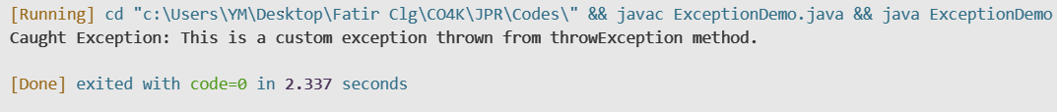

Aim : 3) Write a simple program for throwing our own exception.

Code :-
class MyCustomException extends Exception {
public MyCustomException(String message) {
super(message);
}
}
// Main Class
public class CustomExceptionDemo {
public static void main(String[] args) {
try {
throw new MyCustomException("This is a custom exception
message.");
} catch (MyCustomException e) {
System.out.println("Caught Exception: " + e.getMessage());
}
}
}

OUTPUT :-

Aim : 4) Define an exception called “NotMatchExceptions” that is thrown when a string is not equals to “India”. Write a program that uses this exception.

Code :-
class NotMatchExceptions extends Exception {
public NotMatchExceptions(String message) {
super(message);
}
}
public class India {
public static void main(String[] args) {
try {
checkCountry("USA");
} catch (NotMatchExceptions e) {
System.out.println(e.getMessage());
}
}
public static void checkCountry(String country) throws NotMatchExceptions
{
if (!country.equals("India")) {
throw new NotMatchExceptions("Country does not match: " + country);
}
System.out.println("Country is India.");
}
}

OUTPUT :-

